Dear Customer

Thanks very much for sending me the message earlier. However, I would like a slight clarification on you question about intext (Chao06/1033). I have not placed this citation anywhere in the paper. Kindly clarify. Could it be that we are using different text Readers? This is because, if so, when you download on your end the problem might occur. I am using Microsoft Word 2016 on a windows 10 OS. Kindly clarify this so that I can make the correction very fast. Let me send u a highlighted screen shot for all the intext citations used in the paper. Kindly check below. (all in Harvard Style).

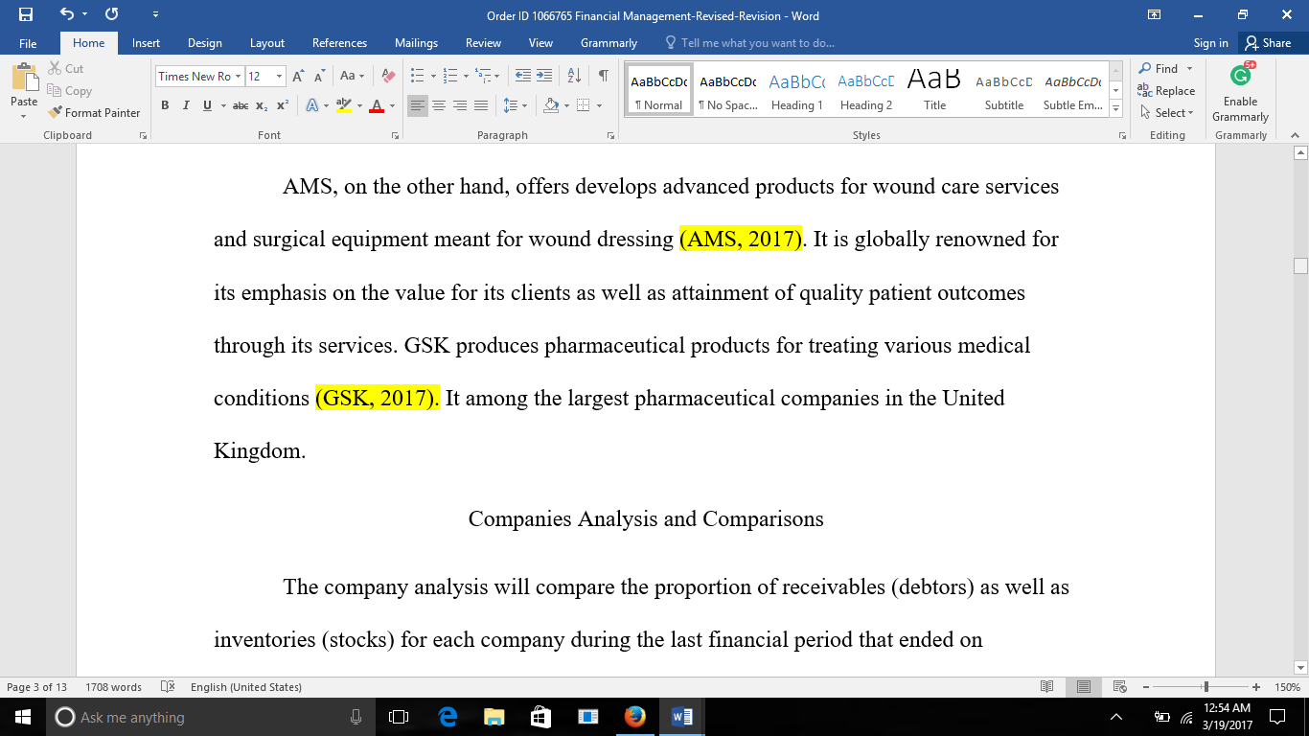 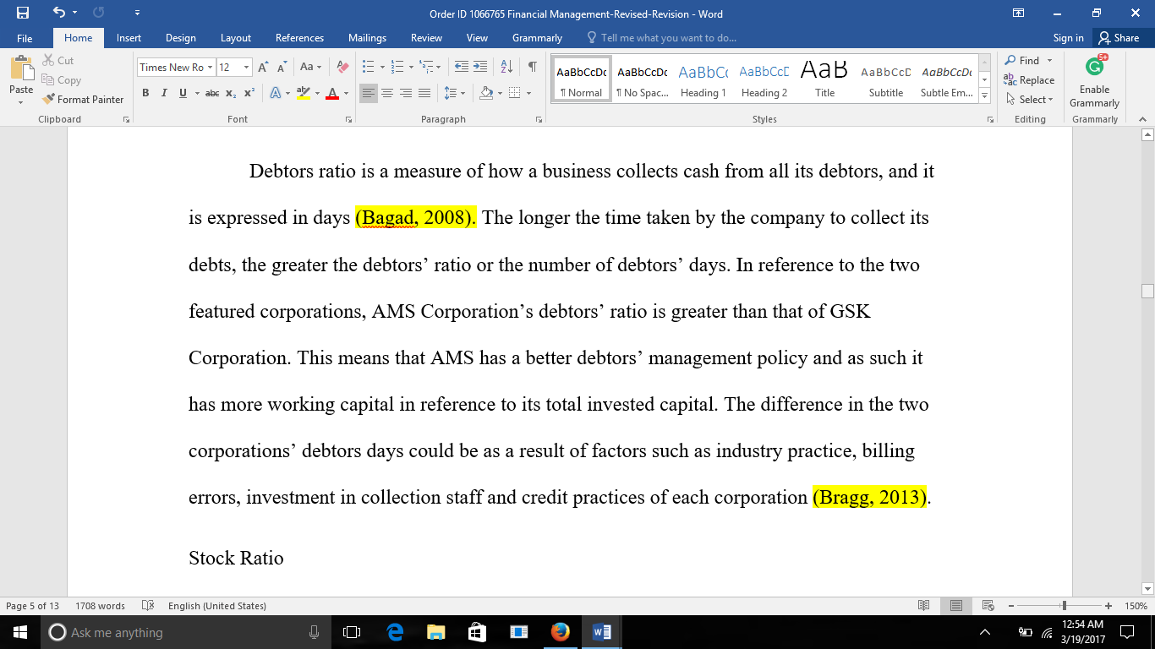 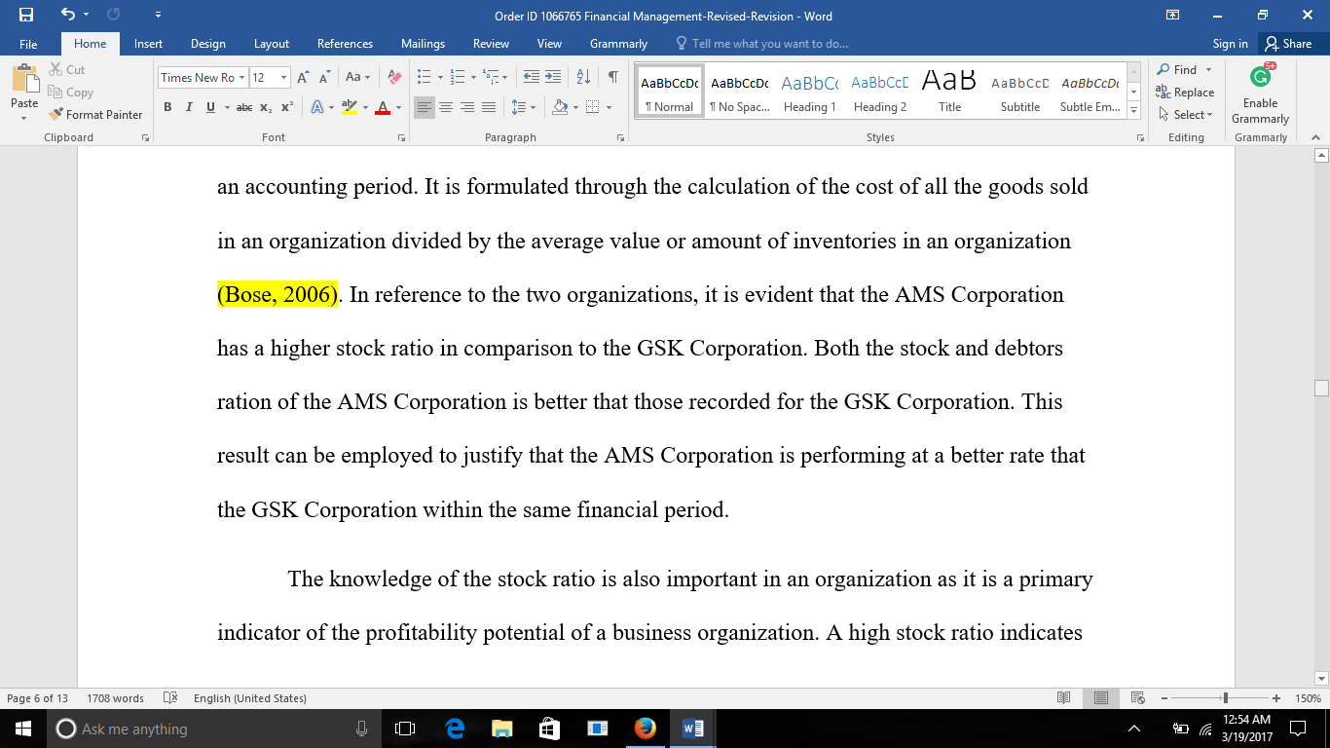 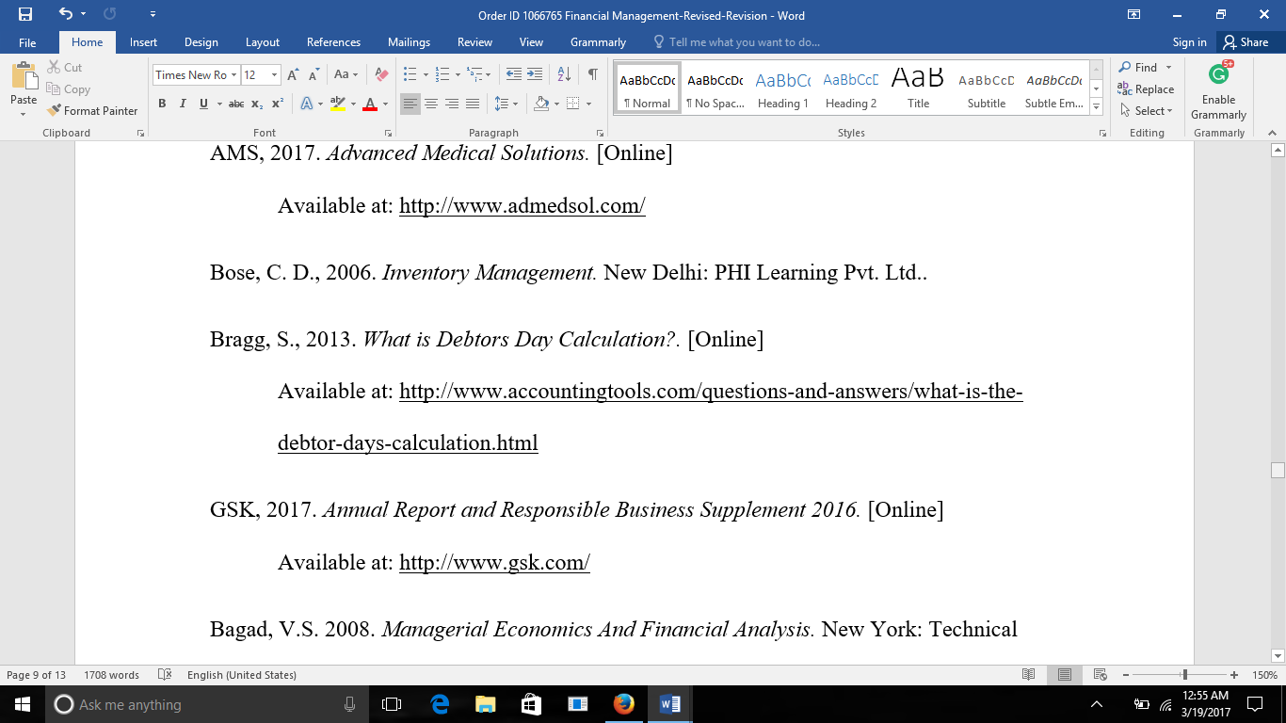

Also. The income and balance statements were obtained from the corresponding official companies website. Let me send you the links below this section.

1. GSK Balance Sheet <http://amigobulls.com/stocks/GSK/balance-sheet/annual>
2. GSK Income Statement <http://amigobulls.com/stocks/GSK/income-statement/annual?t=ibc>
3. AMS Balance Sheet <http://financials.morningstar.com/balance-sheet/bs.html?t=AMS&region=che&culture=en-US>
4. AMS Income Statement <http://financials.morningstar.com/income-statement/is.html?t=AMS&region=che>

